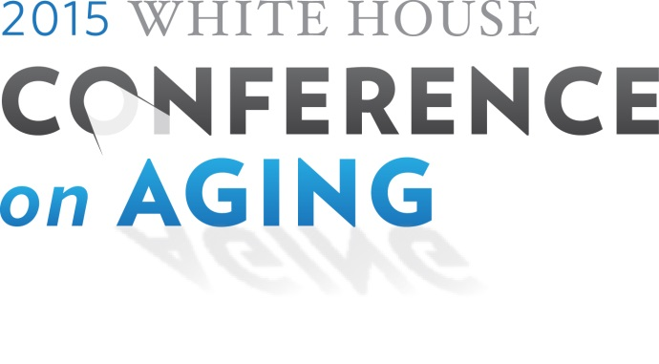
Seattle Regional Forum Agenda
April 2, 2015

All times are Pacific Daylight Time (PDT)

8:30 a.m. Program Begins

9:45 a.m. Administration Keynotes

10:15 a.m. Overview of the White House Conference on Aging and the Day’s Objectives

10:25 a.m. Break

10:35 a.m. Panel Discussion: Healthy Aging/Long-term Supports and Services

11:20 a.m. Panel Discussion: Retirement Security/Elder Justice

12:15 p.m. Live webcast ends

Follow the White House Conference on Aging on Twitter @WHAging
#WHCOA | #LTSS | #HealhtyAging | #RetireSecure | #ElderJustice

